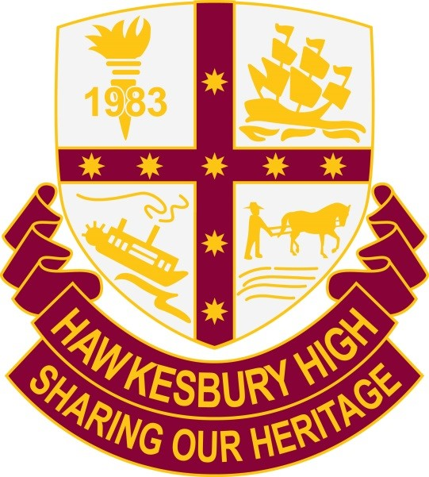

Hawkesbury
High School

School Uniform Code

Hawkesbury High School Uniform

Hawkesbury High School provides a high standard of education, safety and wellbeing for all its students. The Hawkesbury High school community; made up of students, parents and staff, view the wearing of school uniform as integral to maintaining these standards and the STAR (Safe, Team Player, Achiever and Respectful) values of the school.

The aim of these procedures is to ensure that the Hawkesbury High School uniform is worn by all students, that the school uniform at Hawkesbury High School reflects school and community standards as supported by the school's P&C and consistent with WHS, anti-discrimination and equal opportunity legislation.

School Uniform:

- Upholds school identity and promotes equity for all students
- Encourages individual pride in personal appearance and a positive image of the school in the wider community
- Promotes a sense of inclusiveness, non-discrimination and equal opportunity – students are not made to feel different as all students wear the same clothing
- Enables the quick identification of an intruder on school premises and reinforces the obligation to keep all students safe at school
- Protects students when using machinery, equipment or chemicals in practical subjects
- Identifies the school at representative sporting events and excursions
- Prepares students for the work place, as many occupations have a dress code or uniform requirement.

All school uniform items can be purchased at The School Locker shop which is located on the grounds of Hawkesbury High School.

The following are important requirements of the HHS school uniform procedures

- Students need to wear the correct uniform including travelling to and from school each day
- All items of school uniform are to be worn appropriately, respectfully, clean and in acceptable condition
- For timetabled sport or PDHPE practical classes students are to bring the correct HHS sports uniform to change into
- The following items are not permitted: Jeans, leggings, denim shorts, non HHS sport shorts, non HHS track suit pants, cardigans, hooded tops, flannelette shirts/jackets, undershirts or T shirts that extend beyond uniform clothing.
- Zone and representative jackets or pullovers can be worn on a Wednesday only.

Please bring a signed note to the Front Office to explain when out of uniform.

If a student is out of uniform, they will be provided with appropriate clothing and be expected to change.

When a student is out of uniform for any reason, they should have a note signed by a parent or guardian. This note should be brought to the Front Office and shown to the Deputy Principal in the morning before roll call.

Students who are out of uniform and do not have a note from a parent or guardian, will be expected to attend a recess detention and a record of not wearing uniform will be recorded on Sentral. There will also be a conversation with the student to determine why they are out of uniform and if any assistance is required to support the student in obtaining correct uniform.

Families experiencing difficulty can apply for financial assistance. Please see the link to the School Assistance Form on the school’s website.

Senior Girls Sport Uniform
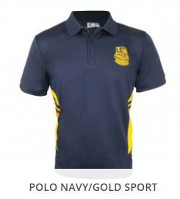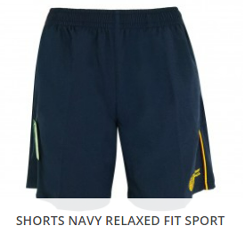

Senior Girls Sport Uniform - required for Representative Events

SHORTS | Navy “HHS” sport shorts with emblem
SHIRT | “HHS” sports shirt with emblem
SHOES | Joggers or sandshoes  (refer to poster indicating required footwear)
SOCKS | White socks

Note: Jeans, hoodies, flannelette shirts, leggings, footy shorts, denim shorts, non HHS sports shorts or non HHS track suit pants are NOT PERMITTED

Senior Girls Uniform
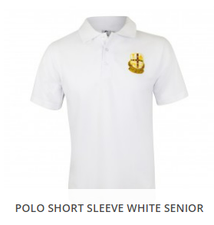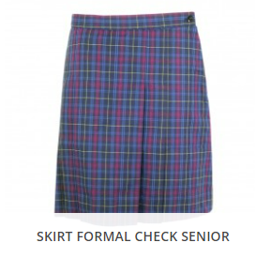
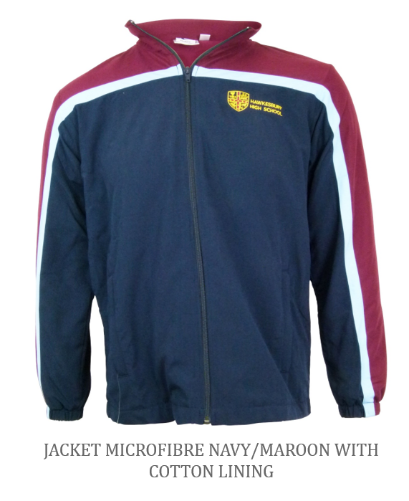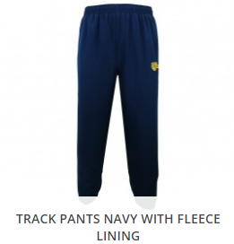
Senior Girls Uniform
SKIRT | Double pleated front blue, maroon & yellow tartan
SHORTS | Tailored plain navy blue shorts - mid thigh to knee length
PANTS | Plain navy blue slacks
HHS Track Pants | Tracksuit Pants navy “HHS” microfibre (Fleece or cotton lining)
SHIRT | White polo shirt with school emblem or white blouse  with school emblem
ZIP JACKET | Navy/maroon/sky blue microfibre jacket with emblem  (lined and unlined versions available) A plain navy or black crew neck (sweatshirt) may be worn under the striped jacket
JERSEY | The senior school jersey may be worn to school, but is not to be worn on special outings without school approval
SHOES | Plain black leather lace up shoes with enclosed toes  (refer to poster indicating required footwear)
SOCKS | Plain white socks for summer or flesh or black coloured stockings under skirt for winter

Note: Jeans, hoodies, flannelette shirts, leggings, footy shorts, denim shorts, non HHS sports shorts or non HHS track suit pants are NOT PERMITTED

Senior Boys Uniform
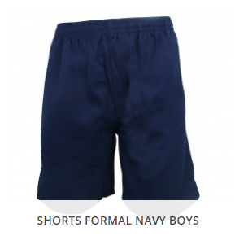

Senior Boys Uniform

PANTS | Navy blue long pants, cargo pants
SHORTS | Navy blue shorts – mid thigh to knee in length
HHS Track Pants | Tracksuit Pants navy “HHS” microfibre (Fleece or cotton lining)
SHIRT | White polo shirt with school emblem or  Plain white shirt with collar and emblem
ZIP JACKET | Navy/maroon/sky blue microfibre jacket with emblem  (lined and unlined versions available) A plain navy or black crew neck (sweatshirt) may be worn under the striped jacket
JERSEY | The senior school jersey may be worn to school, but is not to be worn on special outings without school approval
SHOES | Plain black leather lace up shoes with enclosed toes  (refer to poster indicating required footwear)
SOCKS | Plain white socks

Note: Jeans, hoodies, flannelette shirts, leggings, footy shorts, denim shorts, non HHS sports shorts or non HHS track suit pants are NOT PERMITTED
Senior Boys Sports Uniform
Senior Boys Sports Uniform – required for Representative Events

SHORTS | Navy “HHS” sport shorts with emblem
SHIRT | “HHS” sports shirt with emblem
SHOES | Joggers or sandshoes  (refer to poster indicating required footwear)
SOCKS | White socks

Junior Girls Sport/PE Uniform

Junior Girls Sport/PE Uniform

SHORTS | Navy “HHS” sport shorts with emblem
SHIRT | “HHS” sports shirt with emblem
SHOES | Joggers or sandshoes  (refer to poster indicating correct footwear)
SOCKS | White socks

Note: Jeans, hoodies, flannelette shirts, leggings, footy shorts, denim shorts, non HHS sports shorts or non HHS track suit pants are NOT PERMITTED
Junior Girls Uniform

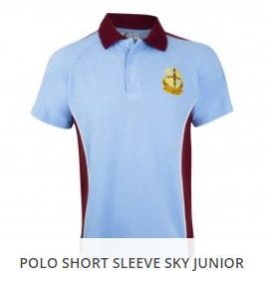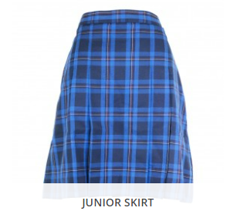
Junior Girls Uniform

SKIRT | Girls skirt large blue check
SHORTS | Tailored plain navy shorts – mid thigh to knee in length
PANTS | Plain navy blue slacks
HHS Track Pants | Tracksuit pants navy “HHS” microfibre (Fleece or cotton lining)
SHIRT | Sky blue & maroon polo shirt with school emblem
JUMPER | Maroon poly/cotton with school emblem
ZIP JACKET | Navy/maroon/sky blue microfibre jacket with emblem  (lined and unlined versions available) A plain navy or black crew neck (sweatshirt) may be worn under the striped jacket
SHOES | Plain black leather lace up shoes with enclosed toes  (refer to poster indicating required footwear)
SOCKS | Plain white socks for summer or flesh or black coloured stockings under skirt for winter

Note: Jeans, hoodies, flannelette shirts, leggings, footy shorts, denim shorts, non HHS sports shorts or non HHS track suit pants are NOT PERMITTED
Junior Boys Uniform
Junior Boys Uniform

PANTS | Navy blue long pants, cargo pants
SHORTS | Navy blue shorts – mid thigh to knee in length
HHS Track Pants | Tracksuit pants navy “HHS” microfibre (Fleece or cotton lining)
SHIRT | Sky blue polo & maroon shirt with school emblem
JUMPER | Maroon poly/cotton with school emblem
ZIP JACKET | Navy/maroon/sky blue microfibre jacket with emblem  (lined and unlined versions available) A plain navy or black crew neck (sweatshirt) may be worn under the striped jacket
SHOES | Plain black leather lace up shoes with enclosed toes  (refer to poster indicating required footwear)
SOCKS | White socks

Note: Jeans, hoodies, flannelette shirts, leggings, footy shorts, denim shorts, non HHS sports shorts or non HHS track suit pants are NOT PERMITTED

Junior Boys Sport/PE Uniform

Junior Boys Sport/PE Uniform

SHORTS | Navy “HHS” sport shorts with emblem
SHIRT | “HHS” sports shirt with emblem
SHOES | Joggers or sandshoes  (refer to poster indicating required footwear)
SOCKS | White socks

Uniforms are available
for purchase from:-

The School Locker

The School Locker shop is located on the
Hawkesbury High School grounds
near the Administration Block

Opening Hours:
Tuesdays - 8.15am to 10.15am
Thursday - 8.15am to 10.15am
